SYNOPSIS

**GROUP 7**

#### **Project Name:**

#### **EASY BUS** -Seat Reservation Platform for Short Distance Bus Services.

#### **Project Overview:**

In bustling cities like Bengaluru, the daily commute can be a challenging experience, especially when it comes to securing a seat on a bus. With overcrowded public transport systems and high demand during peak hours, many commuters struggle to find a seat, leading to an uncomfortable and often stressful journey. Our Bus Ticketing System aims to tackle this problem by introducing a user-centric platform specifically designed to streamline the bus ticket booking process for short-distance routes.

#### **The Problem:**

In many busy urban areas, buses are often packed to capacity, particularly during rush hours. Commuters frequently face difficulties in finding available seats, which can result in long and tiring journeys, particularly for those traveling to work or school. This issue is compounded by the lack of options for reserving seats in advance for short distances. Most existing bus ticketing apps and systems focus on long-distance travel, leaving daily city commuters with limited options for ensuring a comfortable ride.

#### **Our Solution:**

To address this issue, our Bus Ticketing System will allocate a portion of bus seats (currently set at 6 seats per bus) exclusively for online booking through our platform. These seats can be reserved in advance, ensuring that users have a guaranteed seat on the bus, even during the busiest times of the day. Recognizing the value of convenience and comfort, these reserved seats will be available for a slightly higher payment compared to standard fare prices.

By offering this service, we aim to provide a practical solution to the overcrowding problem faced by city commuters. The ability to book a seat in advance will not only enhance the comfort of the journey but also save time and reduce stress for daily travelers. Our system is designed to be user-friendly, allowing commuters to easily check bus availability, select their preferred seat, and complete their booking in just a few clicks.

#### **Impact:**

Our Bus Ticketing System is designed to make daily commuting more comfortable and efficient. By providing the option to reserve seats on short-distance buses, we address a significant pain point for city commuters. This innovative approach not only improves the user experience but also encourages more people to use public transport, potentially reducing traffic congestion and contributing to a more sustainable urban environment.

**Objective of the Project:**

**1.Real-time Bus Availability:** Enable users to check real-time availability of buses for both short and long-distance journeys without any minimum distance restrictions.

**2.User-friendly Interface:** Develop an intuitive and easy-to-navigate user interface to enhance the user experience, making it simple for users to find the best bus options and deals.

**3.Seamless Seat Booking:** Provide users with the ability to view and select seat options for both short and long-distance journeys, ensuring flexibility and convenience in booking.

**4.Guaranteed Seats:** The allocation of reserved seats for online booking ensures that users can avoid the hassle of finding a seat during peak hours.

**5.Convenient Payment Options:** Users can choose to pay online through Razorpay or opt for on-board payment, adding flexibility to the booking process.

**6.Accurate Route Information:** Offer reliable and accurate route and direction information, helping users plan their journey efficiently and without frustration.

**7.Comprehensive Service:** Bridge the gap between short-distance and long-distance bus services, allowing users to book tickets and view routes for any journey type, enhancing the overall accessibility of the service.

**Challenges:**

* Minimum distance limit.
* Challenges with the user interface.
* Inaccurate Directions and Routes
* Lack of Online Seat Booking

**Solutions:**

* Seat Reservations for Short Distances
* On-Board Payment
* Special Reservations for Senior Citizens

**Data Workflow:**

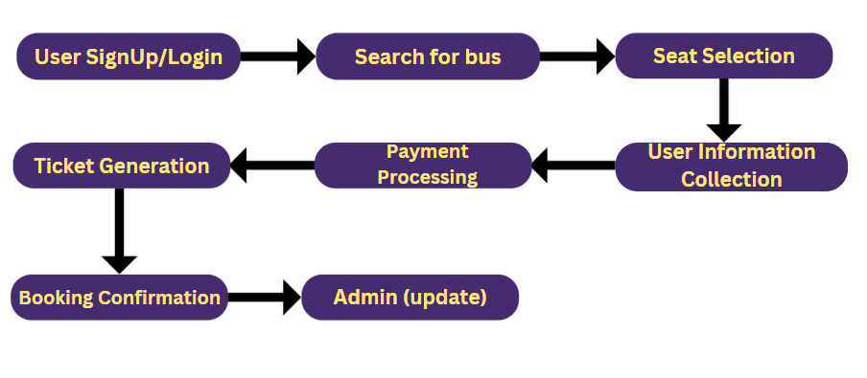

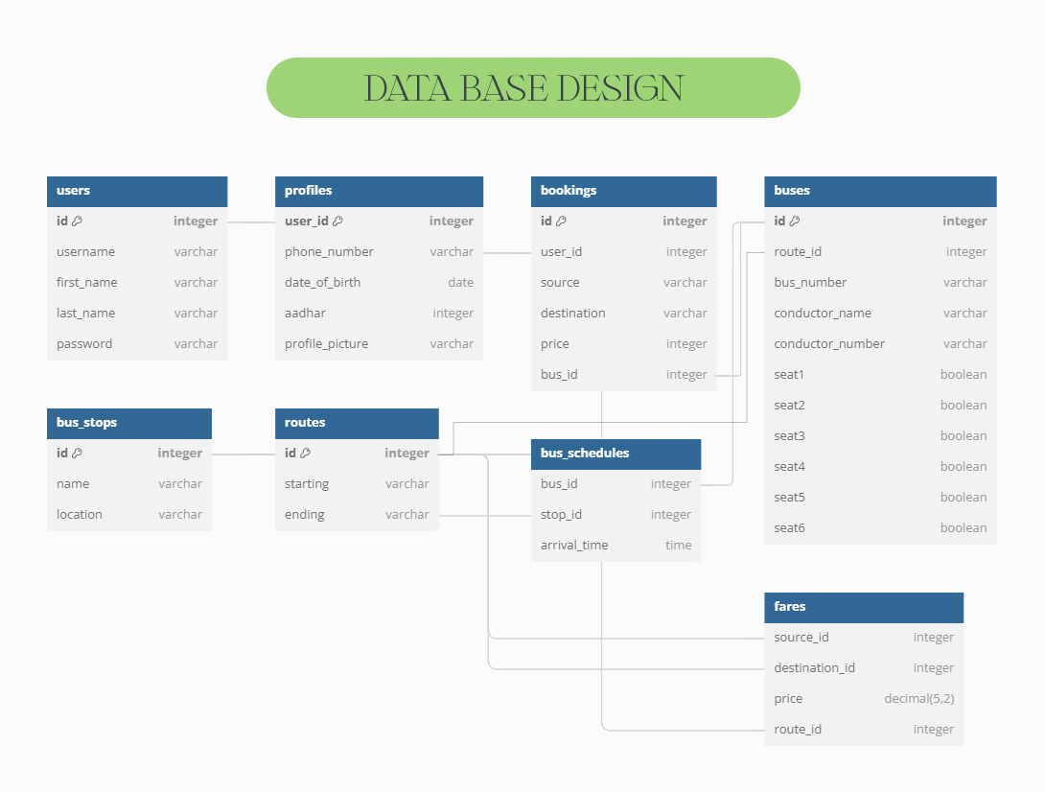

**Technology Stack**

#### **Backend:**

* **Django (Python):**The core backend framework for building the web application, handling routing, database interactions, and business logic.
* **Django Rest Framework (DRF):**To build RESTful APIs, which will enable the frontend to interact with the backend and manage data efficiently.
* **PostgreSQL:**A robust and scalable relational database system used for storing user data, bookings, routes, bus information, and other related data.

#### **Frontend:**

* **HTML/CSS/JavaScript:**For creating the user interface and ensuring a responsive and user-friendly experience.
* **Bootstrap:**A front-end framework that helps in designing a responsive and mobile-first website.
* **jQuery:**To simplify DOM manipulation, event handling, and AJAX interactions.

#### **Data Processing & Integration:**

* **Pandas (Python):**For processing and integrating the Excel file containing price charts. It will help in reading, manipulating, and updating fare information within the system.

#### **Payment Gateway:**

* **Razorpay API:**To handle online payments. The Razorpay API will be integrated into the system to enable users to pay for their bookings securely and efficiently.

#### **Maps & Location Services:**

* **Google Maps API (Potential):** To provide accurate directions, display routes, and enhance location-based services within the app. This API can help users visualize the bus routes and stops on a map.

#### **Deployment & Infrastructure:**

* **Terraform:**For Infrastructure as Code (IaC), used to provision and manage the cloud infrastructure where the application will be deployed.
* **AWS:**For hosting the application, database, and related services in a scalable and reliable environment.
* **Docker:**For containerizing the application, ensuring consistency across different environments, and simplifying the deployment process.

#### **Authentication & Security:**

* **Django Allauth/Django OAuth:**For handling user authentication, including social logins and standard email/password logins.
* **SSL/TLS:**To secure data transmission between the client and server, ensuring that all sensitive data, including payment details, are encrypted.

#### **Version Control & Collaboration:**

* **Git:**For version control, enabling collaborative development and maintaining the codebase.
* **GitHub/GitLab/Bitbucket:**To host the repository, manage issues, and facilitate team collaboration.

**System Architecture**

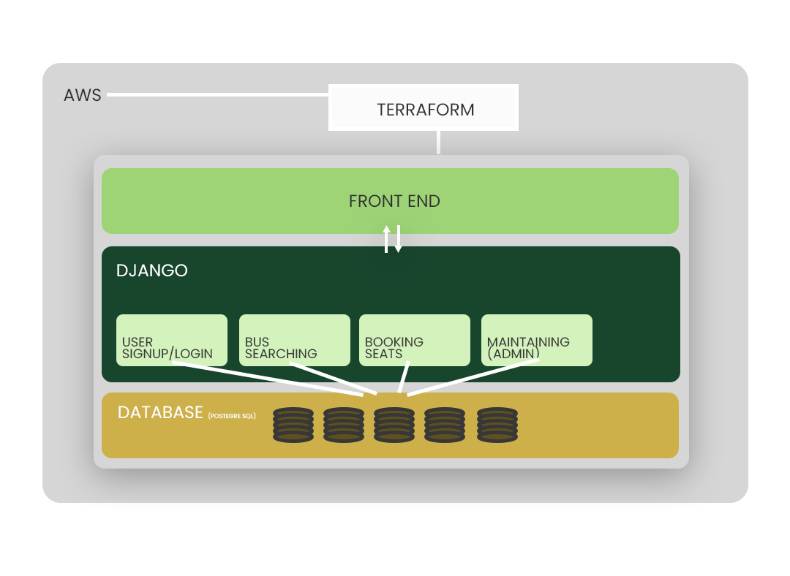

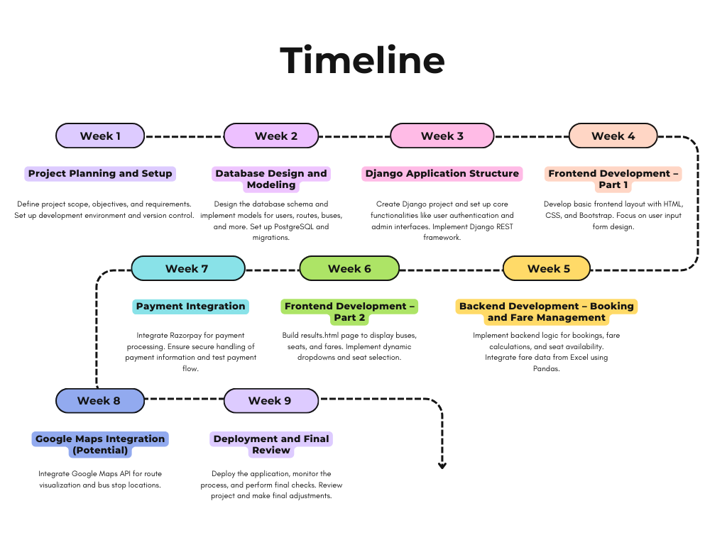

**Future Enhancements**

### **Integration with Other Transportation Modes**

* Multi-Modal Transport: Integrate with other transportation services such as metro, taxi, or bike-sharing systems, allowing users to plan their entire journey seamlessly within a single app.
* Real-Time Transit Information: Provide real-time updates on the arrival and departure of buses, including delays and estimated arrival times.

### **Improved Accessibility Features**

* **Voice Assistance:** Add voice search and navigation features for users with disabilities or those who prefer voice commands.
* **Language Support:** Offer multi-language support to cater to users from diverse linguistic backgrounds.

### **Smart Route Optimization**

* **AI-Powered Route Suggestions:** Use AI to suggest the fastest or most convenient routes based on real-time traffic conditions and user preferences.
* **Customizable Alerts:** Allow users to set custom alerts for specific routes, times, or fare changes to stay updated on their preferred travel options.

**Conclusion**

The Bus Ticketing System project successfully addresses the growing need for a convenient and efficient way for users to book bus tickets online. By offering a user-friendly interface and streamlined booking process, the system enhances the overall travel experience for customers. Users can easily choose their desired seats, and make secure payments.

This project not only simplifies the ticketing process but also reduces manual errors associated with traditional booking methods. With real-time seat availability updates and automated ticket generation, the system ensures accuracy and reliability.

In conclusion, the Bus Ticketing System is a significant step towards modernizing public transportation services. It provides a practical solution that meets the needs of both users and service providers, paving the way for a more connected and efficient travel network.